EPITOME MODEL ISLAMIC SCHOOLS
2ND TERM EXAMINATION FOR
SENIOR SECONDARY SECTION
2024/2025 ACADEMIC SESSION
BIOLOGY

Name: | Class: Year 10(S.S.S 1) | Time Allowed: 2hours
FOR MARKERS ONLY
Sections in Paper | Scores Obtainable | Scores Obtained
Section A (Objectives)
Section B (Theory)
Total Scores
Do not start until you are told to do so

SECTION A – ANSWER ALL QUESTIONS
- Fungi(mushroom) obtains its food from dead organic matter extracellularly. It is said to be
(a)facultative parasite (b)saprophyte
(c)obligate parasite (d)autotrophy

- 6CO₂ + 6H₂O $\frac{sunlight}{chlorophyll }$ C₆H₁₂O₆ + 60₂ . The process above represents
(a)proteinsyntheis (b)respiration
(c)photosynthesis (d)transpiration

- Which of the following is not correct about the living cell?
(a)All the cells in living organisms are the same
(b)The basic unit of a living organism is the cell
(c)All living organisms are either single celled or group of cells
(d)There is no life apart from the life of cells

- A major reason the red blood cells (RBC) can survive in the blood is that the
(a)blood plasma and the red blood cells are isotonic
(b)red blood cells are hypotonic to the blood plasma
(c)the red blood cells receive digested nutrients
(d)blood plasma is hypotonic to red blood cells

- Which of the following organism has both plant and animals characteristics?
(a)Paramecium (b)Amoeba
(c)Euglena (d)Spirogyra

- Pairing is a common reproductive behavior of the following except
(a)man (b)toads
(c)winged termites (d)none of the above

- If an isolated living cell is placed in distilled water for two hours, it will likely
(a)lose some of its water to the surrounding water
(b)lose all of its water to the surrounding water
(c)become more turgid
(d)die due to excess water
- One of these does not affect the rate of diffusion
(a)Colour (b)Temperature (c)Stiring (d)Shaking

- Diffusion is only possible in one of the following state
(a)Solid (b)Liquid (c)Gaseous (d)All of the above

- One of these will not allow osmosis to take place
(a)Cow’s bladder (b)Cellophane
(c)Pig’s bladder (d)Transparent polythene

Use the diagram below to answer questions 11-12
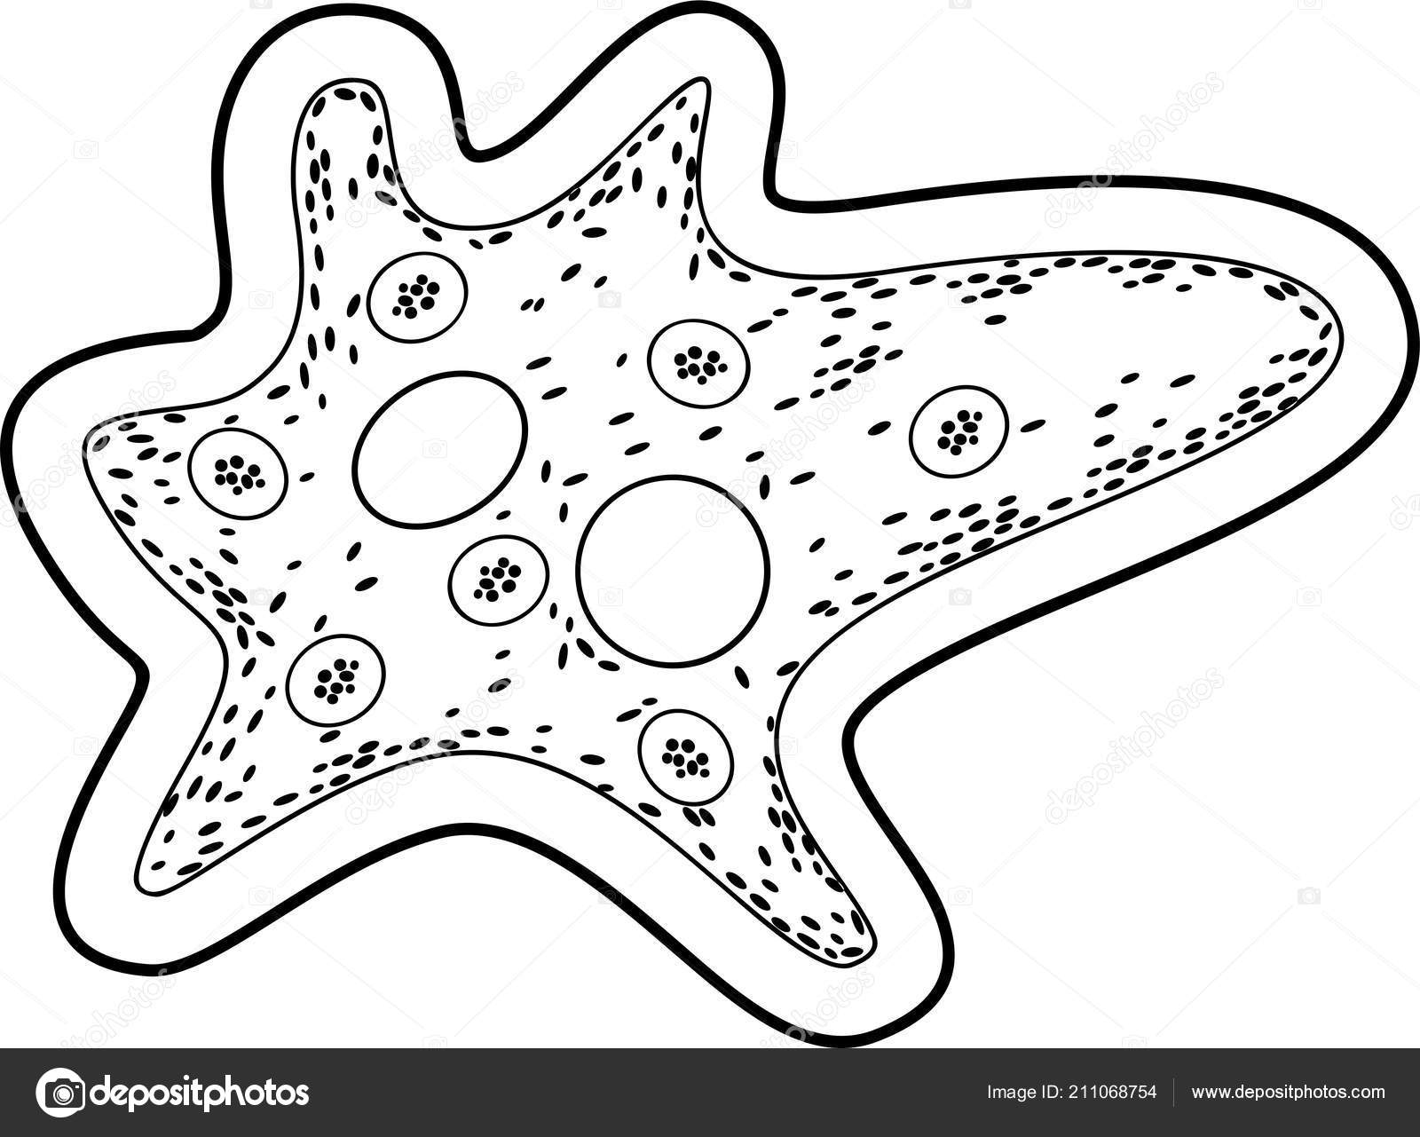
III
I

II

IV

V

- The organism illustrated above is
(a)paramecium (b)amoeba
(c)euglena (d)chlamydomonas

- During reproduction, the first structure to divide is
(a)I (b)II (c)III (d)V

- Which of the following groups embraces the rest?
(a)Class (b)Phylum (c)Kingdom (d)Species

- The main similarity between unicellular organism and multicellular organism is that both
(a)exist as colories (b)are plants
(c)exist as filaments (d)perform all life processes

- One of these defines plasmolysis
(a)Shrinking away of cytoplasm from the cell wall of plants
(b)Shrinking of a plant cell in a solution
(c)Shrinking away of cytoplasm from the animal cell wall
(d)Shrinking of the vacuole leaving the cytoplasm attached to the cell wall

- Turgidity in the cell of plant does not lead to bursting of the cell because the
(a)cellulose cell wall resist turgidity
(b)cell membrane can resist turgidity
(c)large vacuoles contained in the cell can continuous take in water
(d)cytoplasm is jelly-like

- A piece of cassava tuber weighing 2.0g was put into salt solution. After two hours, the piece weighed 2.5g. this demonstrates that the
(a)salt solution is more concentrated than the cell sap of the cassava
(b)cell sap of the cassava is more concentrated than the salt solution
(c)the cassava lost some water to the salt solution
(d)salt solution is isotonic to the cell sap of the cassava

- One of these is a tissue
(a)Volvox (b)Paramecium
(c)Epicermis (d)Chlamydomonas

- Which of the following characteristics is not possessed by most plants?
(a)Respire
(b)Reproduce
(c)Move away from stimuli
(d)Adapt to environment

- The phylum Mollusca is characterized by the presence of
(a)jointed appendages (b)back bones
(c)star-shaped bodies (d)soft unsegmented bodies

- Which of the following statement is correct about organs
(a)They are composed of specialized cells
(b)They are not found in plant
(c)Unicellular animals have few organs in plant
(d)They perform a certain overall function

- Carbohydrates are stored in animal cells in the form of
(a)starch (b)glycogen (c)plastid (d)maltose

- A change in the environmental condition of an organism is termed
(a)impulse (b)stimulus (c)response (d)sensitivity

- Respiration is an essential life process providing the living cell with
(a)oxygen (b)carbon (c)sugars (d)energy

- In binomial system of naming, organism’s second name is often the
(a)scientific name (b)generic name
(c)common name (d)specific (species)

- Ecology means
(a)the properties of a habitat
(b)interrelationship between organisms nd their environment
(c)several species of plants and animal
(d)interrelationship between plants and animals

- Which of the following process takes place when a plant cell is put in a hypotonic solution?
(a)Water moves into the cell and the cell burst
(b)Water moves into the cell and the cell becomes turgid
(c)Water leaves the cell and the cell becomes flaccid
(d)The cell becomes plasmolysed

- Which of the following definitions best describes excretion? The
(a)liberation of energy from food
(b)removal of waste products of metabolism
(c)release of faeces from the body
(d)breaking down of food molecules

- The mechanism of gaseous exchange in living organisms is essentially by
(a)diffusion (b)osmosis
(c)inhalation (d)expiration

- The process of anaerobic respiration of yeast in sugar solution is called
(a)oxidation (b)fermentation
(c)decomposition (d)tissue respiration

- The passage of water across a selective permeable membrane is called
(a)active transport (b)osmosis
(c)facilitated diffusion (d)pinocytosis

- At which of the following stages of cell division, is the cell said to be resting?
(a)prophase (b)metophase
(c)interphase (d)anaphase

- The upper part of the trachea in mammals is called
(a)palate (b)larynx (c)bronchus (d)epiglottis

- The movement of diaphragm is a characteristic of gaseous exchange in
(a)insects (b)fish (c)plants (d)mammal

Use the diagram to answer questions 35 and 36
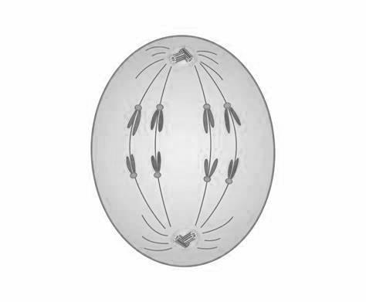
I

II

III

- The diagram above illustrates which stage of cell division?
(a)prophase (b)interphase
(c)telophase (d)anaphase

- The part labelled II is called
(a)centriole (b)chromatid
(c)spindle (d)centrosome

- In cellular respiration, energy is stored in the form of
(a)ATP (b)ADP (c)Heat energy (d)ADH

- Which of these processes remove carbon(iv)oxide from the atmosphere?
(a)Putrefaction (b)Burning of fuel
(c)Photosynthesis (d)Burning of coal

- The bursting of red blood cells when placed in hypotonic solution is called
(a)crenation (b)turgidity
(c)haemolysis (d)plasmolysis

- The stage of mitosis where chromosomes lie at the equator is called
(a)interphase (b)metaphase
(c)prophase (d)anaphase

- One of these enzymes acts on protein substances
(a)Lipases (b)Lactases (c)Proteases (d)Amylases

- The centre of chromosome that holds two chromatids together is called
(a)centromere (b)centriole
(c)spindle (d)chromatid

- The phenomena through which water is absorbed by solid leading to increase in the volume but not forming a solution is called
(a)diffusion (b)osmosis
(c)imbibition (d)facilitated diffusion

- At the end of photosynthesis, the green leaf is tested for starch and not glucose because
(a)the glucose formed is immediately in leaves
(b)starch is stored only in leaves
(c)the glucose is used immediately to provide energy
(d)it is easy to test for starch

- During photosynthesis, light energy is always absorbed by the
(a)shoot (b)enzyme (c)water (d)chlorophyll

- Which of the following indicates that euglena is a plant?
(a)Conspicuous eye spot
(b)Presence of gullet
(c)Presence of starch grains
(d)Limited movement

- The oxygen given off during photosynthesis is derived from
(a)water (b)sunlight
(c)chlorophyll (d)carbondioxide

- A photometer with a leafy shoot weighed 18.9g initially and 17.9g after 1 hour. From this, it shows that
(a)the shoot absorbed 1g of water per hour
(b)1g of water per hour evaporates from the potometre
(c)the shoot lost 1g of water per hour
(d)the shoot was respiring and lost weight at the rate of 1g per hour

- The carries of heredity characters in plants and animals is the
(a)cell (b)nucleus
(c)gene (d)chromosome

- Which of the following is not an excretory organ?
(a)Lungs (b)Leaf
(c)Kidney (d)Large intestine

SECTION B – ANSWER THREE QUESTIONS
- a. Define ecology (2mks)
b. Explain the following:
i. Biotic factor
ii. Abiotic factor
iii. Ecological nicke
iv. Population
v. Community (5mks)
c. Explain ecosystem (3mks)

- a. Define nutrition and nutrients (2mks)
b. Explain macro and micro nutrients with two examples each (4mks)
c. Explain autotrophism and heterotrophism (4mks)

- a. Define respiration (2mks)
b. List and explain two types of respiration (4mks)
c. Outline two differences between the two types of respiration listed in 3b above (4mks)

- a. Define osmosis and diffusion (4mks)
b. Explain the following:
i. Haemolusis
ii. Crenation
iii. Plasmolysis
iv. turgidity
v. Isotonic solution
vi. Hypotonic solution (6mks)

- a. Explain mitosis (2mks)
b. Using diagram only, show metaphase state of mitotic cell division (4mks)
c. Outline four out of the five stages of mitotic cell division (4mks)

